# Topic: Recommendation Engine

**Instructions:**

Please share your answers filled in-line in the word document. Submit code separately wherever applicable.

Please ensure you update all the details:

**Name: _____________ Batch ID:** ___________

**Topic: Recommender Engine**

**Hints:**

1. **Business Problem**
   1. **What is the business objective?**
   2. **Are there any constraints?**
2. 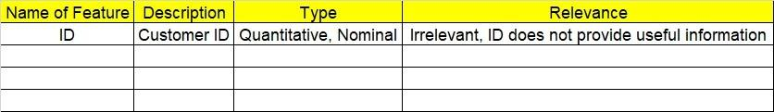**Work on each feature of the dataset to create a data dictionary as displayed in the image below:**
3. **Data Pre-processing**

**2.1 Data Cleaning and Data Mining.**

1. **Exploratory Data Analysis (EDA):**
   1. **Summary.**
   2. **Univariate analysis.**
   3. **Bivariate analysis.**

1. **Model Building**
   1. **Build the Recommender Engine model on the given data sets.**
2. **Write about the benefits/impact of the solution - in what way does the business (client) benefit from the solution provided?**

**Problem Statement: -**

Q) Build a recommender system with the given data using UBCF.

This dataset is related to the video gaming industry and a survey was conducted to build a

recommendation engine so that the store can improve the sales of its gaming DVDs. Snapshot of the dataset is given below. Build a Recommendation Engine and suggest top selling DVDs to the store customers.

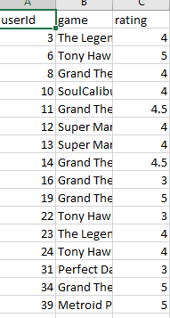

**Problem Statement: -**

The Entertainment Company, which is an online movie watching platform, wants to improve its collection of movies and showcase those that are highly rated and recommend those movies to its customer by their movie watching footprint. For this, the company has collected the data and shared it with you to provide some analytical insights and also to come up with a recommendation algorithm so that it can automate its process for effective recommendations. The ratings are between -9 and +9.

